**CALL FOR ABSTRACTS  
Due Date: 6 April 2020**

COMMERCIALIZATION OF EMERGING TECHNOLOGIES CONFERENCE (COMS2020)

LOCATION: UNIVERSITIES AT SHADY GROVE, ROCKVILLE MARYLAND (SUBURBAN WASHINGTON D.C.)

EVENT DATES: October 19-22, 2020

THEME: COMMERCIALIZATION OF CONVERGING TECHNOLOGIES TO ENHANCE QUALITY OF LIFE

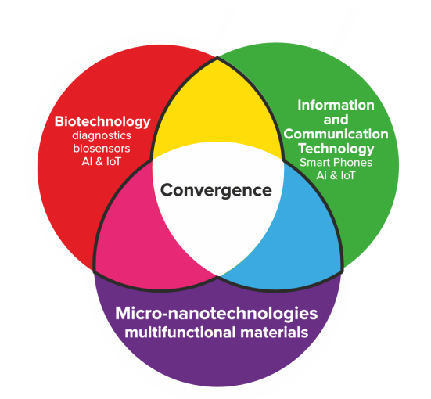The Micro, Nano and Emerging Technologies Commercialization Education Foundation (MANCEF) has selected ‘Commercialization of ConvergingTechnologies to Enhance Quality of Life’ as the overarching theme of its 23rd annual COMS Conference. The adoption of converging technologies has proven to enhance the quality of life for individuals vis-à-vis food and water abundance, reduction of carbon emissions and affordable healthcare. The growth of leveraged technology convergence continues to create differentiated solutions creating an ever-increasing number of new companies. Examples of recent outcomes resulting from the converging of multiple exponential technologies demonstrate that the pace of commercialization dramatically accelerates beyond that made by individual constituent technologies. This phenomenon has been described in the recent NYTimes bestseller, *The Future is Faster Than You Think* (P. Diamandis & S. Kottler, 2020). As an example, contributing technologies as shown in the graphic continue individually to be disrupted by technology advances which can then be leveraged several-fold when combined with other similarly advancing technologies. The significant impact that such technology adoption is having on resilience and sustainability initiatives will also be underscored at the conference.

Examples of derived converging technologies and current applications include the following:

Drones = sensing + actuation + energy storage + A.I.  
MEMS = integration(micro) + sensing + actuation + materials  
A.R. / V.R. = displays + sensing + A.I.  
Gamification = sensing + A.I. + displays   
IoT = sensing + networks + A.I. (data analytics)  
Autonomous mobility = sensing + integration + energy storage + actuation  
Synthetic biology = biotech + A.I. (data processing / analytics)

What is apparent from the myriad of product development and startup activity, extending from converging technology commercialization to the market opportunities they afford, is the need for new training, marketing, funding and business model approaches. The barriers and opportunities to these will be addressed through case study presentations and open discussion at the conference. An exciting aspect of convergent technologies is that they provoke the need for new educational training methodologies.

Abstracts of length 150-200 words that address the topics of converging technologies are requested to be received no later than April 6. These could include case studies in the following areas or others that are associate.

digital healthcare

digital / additive manufacturing

efficient agri /aqua culture

MEMS and sensor-enabled apps

information and national security

smart city, resilient and sustainable infrastructure

environmental monitoring

autonomous systems

Presentations from areas that support commercialization such as licensing, education, infrastructure and clusters, funding and grant opportunities issues are also welcomed. The submission should include a description of how health, security and/or environment are aided by this commercialization effort. Please go to [www.mancef.org/coms2020/](http://www.mancef.org/coms2020/) to upload and submit your abstract.

Notification of abstract selection will be made by April 27. All selected authors will be provided with a presentation slot in the COMS2020 program and will have their abstract and bios published in a conference book of abstracts.

The COMS 2020 venue will also play host to a small technology exhibit.

For details regarding conference registration, sponsorship and exhibit opportunities, please visit [www.mancef.org/coms2020/](http://www.mancef.org/coms2020/)

**COMS2020 SPONSORS**

|  |  |  |  |  |
| --- | --- | --- | --- | --- |
| **GOLD SPONSORS** | | **BRONZE SPONSOR** | | |
|  |  | |  | |
|  |  | |  |  |
|  |  | |  |  |